**Chapter one: Introduction**

**Background:**

Exams are a critical component of assessing students' knowledge and understanding of various subjects. However many students face difficulties in preparing effectively for exams which can lead to unsatisfactory results and even failure. Traditional study methods and resources may not always leads to the specific needs and learning styles of individual students.

Furthermore, students often struggle to identify their areas of weakness and find it challenging to improve upon them. They may lack access to targeted resources or personalized guidance that can help them address their knowledge gaps and enhance their understanding of key concepts. Additionally, the lack of opportunities for collaborative learning and discussion can limit students' ability to engage deeply with subject matter and gain different perspectives.

Motivated students are more likely to perform well academically and overcome challenges. However, maintaining motivation throughout the learning process can be difficult, especially in the face of setbacks or the monotony of exam preparation. Students may benefit from motivational resources that inspire and uplift them, reminding them of the importance of their education and encouraging them to persist in their efforts.

To address these challenges and enhance the exam preparation experience, this project aims to develop an application that provides a comprehensive solution. the application will offer a range of exams covering diverse topics, personalized recommendations for topic improvement, a platform for collaborative question discussions, and motivational resources. The goal is to empower students to prepare effectively, identify and address their weaknesses, engage in meaningful discussions, and stay motivated throughout their learning journey.

**Statement of the Problem**

The problem that many students face challenges in effectively preparing for exams, leading to unsatisfactory results and a high rate of exam failure. These challenges include:

1. **Lack of effective exam preparation:** Many students struggle to organize their exam preparation efforts, resulting in an inefficient approach. They may not have access to comprehensive self-accessing materials or guidance on how to structure their study time effectively.

2. **Difficulty in identifying areas for improvement:** Students often find it challenging to identify their areas of weakness and prioritize topics that require further attention. Without a clear understanding of their knowledge gaps, they may not be able to focus their efforts on improving those areas.

3. **Limited opportunities for collaborative learning and discussion:** Engaging in discussions with peers and subject matter experts can enhance understanding and provide alternative perspectives. However, students often lack platforms or opportunities for meaningful question discussions.

1. **Lack of motivation**: Exam preparation can be a demanding and many students struggle to maintain motivation throughout. The absence of motivational resources and support systems can contribute to a decline in effectiveness.

**Motivation**

The motivation behind this project is to decrease the number of students who fail exams. Failing an exam can have a detrimental impact on students' academic progress, self-confidence, and future opportunities. We believe that every student deserves a fair chance to succeed and that with the right support and resources, they can overcome challenges and achieve their academic goals.

By developing an application that offers comprehensive exam preparation resources, personalized topic improvement recommendations, collaborative question discussions, and motivational resources, we aim to provide students with the necessary tools and support to increase their chances of success.

We envision a future where students feel confident and well-prepared for their exams, where they have access to targeted resources that help them identify and address their weaknesses, and where they can engage in meaningful discussions with their peers and experts to enhance their understanding. Additionally, we aim to instill a sense of motivation and inspiration in students by providing them with motivational resources such as quotes that encourage a positive mindset throughout their learning journey.

**Objectives**

**General Objective**

The general objective of this project is to develop an application that facilitates effective exam preparation, topic improvement, question discussions, and provides motivational resources, with the ultimate goal of reducing the number of students failing exams.

**Specific Objectives:**

1. Provide a variety of exams with diverse topics to cater to different learning needs: The application will offer a comprehensive selection of exams covering a wide range of subjects and topics. This will ensure that students have access to a diverse set of exam materials that align with their specific learning needs and educational requirements.

2. Offer personalized recommendations for topic improvement based on the user's performance and areas of weakness: The application will utilize user performance data and algorithms to provide personalized recommendations for areas of improvement. By analyzing the user's performance in previous exams or assessments, the application will identify specific topics or concepts that require further attention and provide targeted resources to enhance understanding and proficiency.

3. Create a platform for users to engage in meaningful discussions under specific questions, fostering collaborative learning: The application will include a discussion feature where users can participate in discussions related to specific questions or topics. This will facilitate collaborative learning, allowing students to exchange ideas, clarify doubts, and gain different perspectives, thereby enhancing their overall understanding of the subject matter.

4. Provide a collection of motivational resources, such as quotes to inspire and uplift users throughout their learning journey: The application will feature a dedicated section for motivational resources. It will curate a collection of inspiring quotes or other uplifting content to motivate and encourage students during their exam preparation. These resources will aim to develop a positive mindset, supporting students in overcoming challenges and staying motivated.

By achieving these specific objectives within the broader goal, the application aims to provide students with a comprehensive learning experience that enhances their exam preparation, addresses their individual learning needs, fosters collaboration, and provides the necessary motivation to increase their chances of success while reducing the number of students who fail exams.

**Significance of the Project**

The project holds significant importance due to the following reasons:

1. **Academic Success:** By developing an application that focuses on effective exam preparation, topic improvement, question discussions, and motivation, the project aims to contribute to improved academic success. Reducing the number of students who fail exams can have a positive impact on their educational journeys, enabling them to progress and achieve their academic goals.
2. **Develop Self-confidence:** Exam failure can be demoralizing and negatively impact students' self-confidence. the project aims to empower students to address their weaknesses, enhance their understanding, and build confidence in their abilities.
3. **Collaborative Learning:** The project facilitates meaningful question discussions. By enabling students to engage with their peers and subject matter experts, the project promotes knowledge sharing, critical thinking, and a deeper understanding of the subject matter.
4. **Motivation:** Motivation plays a crucial role in academic success. By providing a collection of motivational resources.

**Scope of the Project**

The scope of the project includes the development of an application that focuses on exam preparation, topic improvement, question discussions, and motivation. The project encompasses the following key aspects:

1. **Exam Preparation**: The application will provide a comprehensive selection of exams covering various subjects and topics. The exams will be designed to cater to different educational levels and learning needs.
2. **Personalized Recommendations:** Based on the user's performance in exams or assessments, the application will provide personalized recommendations for topic improvement.
3. **Question Discussions:** The application will include a platform for users to engage in discussions related to specific questions or topics. Users can post questions, provide answers, and participate in discussions with their peers and subject matter experts.

**4. Motivational Resources:** The application will provide a collection of motivational resources such as quotes or other uplifting content.

The project's scope may also include features such as user profiles, progress tracking, performance analytics, and a user-friendly interface for seamless navigation and interaction within the application.

Overall, the scope of the project focuses on developing an application that enhances exam preparation, provides personalized recommendations, fosters question discussions, and offers motivational resources, with the goal of supporting students in their academic pursuits and reducing the number of exam failures.

**Limitation**

While the project aims to provide a comprehensive solution to enhance exam preparation and address various challenges faced by students, it is important to acknowledge its limitations:

**1. Subject Coverage**: The application's exam materials and resources may not cover every subject or topic extensively.

**2. Human Interaction:** While the project includes a platform for question discussions, it does not replace the benefits of face-to-face interaction with teachers or peers. this may limit the depth of understanding.

**3. User Commitment and Engagement:** The project's impact is dependent on the user's commitment, user's active participation and dedication are crucial for maximizing the benefits.

**4. Continuous Updates:** The project's exam materials and resources may require regular updates to align with changing newly released exam.

It is important to consider these limitations while utilizing the project's resources and understanding that it serves as a supplementary tool rather than a comprehensive solution to all aspects of exam preparation and learning.

**Chapter two: Requirement Model**

**2.1.1 Functional Requirement**

1. Allow students to login
2. Provide questions with official answer
3. Allow students to post questions that they are having problem with
4. View Their own Profile, progress and edit it
5. Provide daily quote
6. Show area that should be improved
7. Discuss on a problem that is released by student.
8. Allow admin of the application to submit new questions.

**2.1.2 Non-Functional Requirement**

1. **Performance:** System should respond fast when user interact, low latency and efficient handling of requests.
2. **Security:** User data, including login credentials and personal information, should be stored and transmitted securely. System should use proper authentication and authorization to protect sensitive information.
3. **Usability:** User interface should be easy to use, navigate, and visually attractive for good user experience.
4. **Compatibility:** System should work with different web browsers, operating systems, and devices for wide accessibility.
5. **Maintainability:** System should have clean and modular code for easy maintenance, updates, and future extensions.
6. **Data Integrity:** System should ensure accuracy and consistency of data, by implementing data validation and error handling measures.

**Compliance:** System should follow relevant laws, regulations, and industry standards, like data protection and privacy regulations.

**2.2 Use-case model**

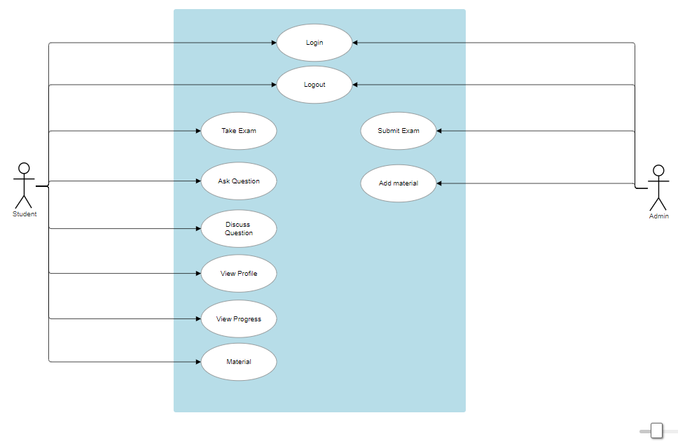

**2.3 Use-case Description**

**Use Case Name:** View Profile

**Actors:** Student

Summary: The student can view their account profile.

**Precondition:**The student is logged into the system.

**Main Sequence:**

1. The student selects the "Account" or "Profile" option from the dashboard.
2. Description: The student clicks on the profile option to view their profile details.
3. The system retrieves and displays the student's profile information, including:

* Username
* Email address
* Grade level or other relevant academic details

**Post-condition:**

* The student's profile information is successfully displayed to the user.
* The student can now view and access the details of their account.

**Use Case Name:** Take Exam

**Actors:** Student

Summary: The student takes an exam for practice in preparation for a national exam.

**Precondition:**

The student is logged into the system and has selected the subject they want to take the exam for.

**Main Sequence:**

1. The student clicks on the "Take Exam" button to navigate to the exam page.
2. The student selects the subject they want to take the exam for.
3. The system processes the selected subject.
4. The system displays the exam questions for the selected subject to the student.

**Post-condition:**

* The exam is displayed to the student, allowing them to take the practice test.
* The student can now complete the exam and receive their results.

**Use Case Name:** Ask Question

**Actors:** Student

**Summary:** The student posts a question that is difficult for them to discuss with other students.

**Precondition:** The student is logged into the system and navigates to the "Ask Question" functionality.

**Main Sequence:**

1. The student writes their question in the provided text box.
2. The student clicks the "Submit" button.
3. The system saves the question in the database.
4. Other users can now retrieve and view the posted question.

**Post-condition:**

* The question is successfully stored in the database and is available for other users to access.
* The student who posted the question has submitted it to the system.

**Use Case Name:** Submit Exam

**Actors:** Admin

**Summary:** The admin submits a new question to the system.

**Precondition:** The admin is logged into the system.

**Main Sequence:**

1. The admin clicks the "Submit Question" button.
2. The admin selects the subject/category for the question.
3. The admin writes the question text in the provided text box.
4. The admin clicks the "Submit" button to send the question to the system.

**Post-condition:**

* The question is logged into the database for further processing.

**Use Case Name:** Discuss with Question

**Actors:** Student

**Summary:** The student discusses a question that is difficult with other students to try to solve the problem.

**Precondition:** The student is logged into the system.

The student navigates to the question posted by other students.

**Main Sequence:**

1. The student navigates to the question discussion page.
2. The student selects a specific question to discuss.
3. The system retrieves the details of the selected question.
4. The system displays the question details and existing discussions to the student.
5. comments or discussions.
6. The student writes a comment or response to the question.
7. The student submits the comment.
8. The system saves the student's comment in the database.
9. The system updates the discussion thread with the new comment.

**Post-condition:**

* The student's comment is successfully stored in the database and displayed as part of the discussion thread.
* Other students can now see and respond to the newly added comment

**Use Case Name:** Login

**Actors:** Student, Admin

**Summary:** The student or admin logs into the system using their credentials.

**Precondition:** The user must have a registered account with valid credentials.

**Main Sequence:**

1. The user navigates to the login page.
2. The user enters their username and password.
3. The user clicks the "Login" button.
4. The system verifies the entered credentials.
5. The system grants access if the credentials are valid.
6. The system denies access if the credentials are invalid.

**Post-condition:**

* If successful, the user is logged into the system and can access authorized functionalities.
* If unsuccessful, the user remains on the login page with an error message displayed

**Chapter three: Analysis Model**

1. **Sequence Diagram**

**Use-case name: login**

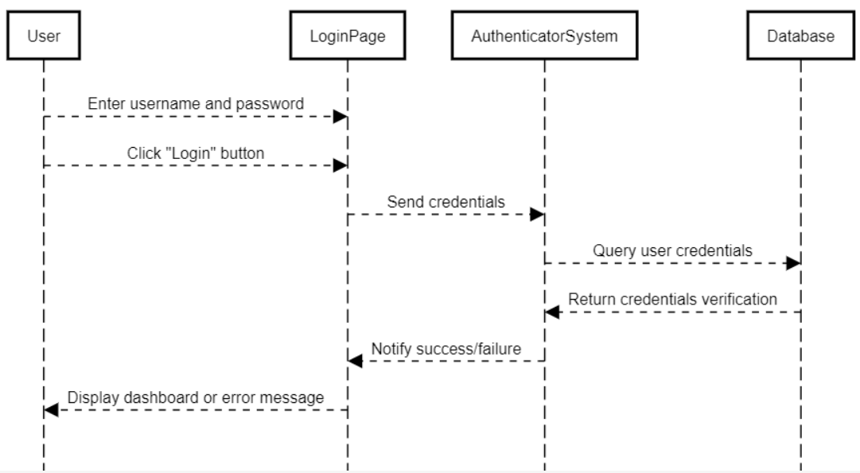

**Use-case name: profile**

